Presbytery of the Peaks

108 Melinda Drive

Lynchburg, VA 24502

1-888-557-3257 or (434)845-1754

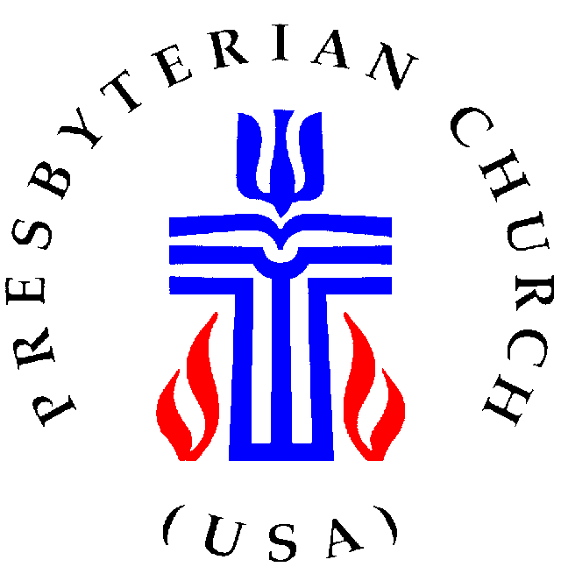

INSTRUCTIONS FOR

SESSION ANNUAL STATISTICAL REPORT

FOR THE YEAR 2018

PLEASE NOTE: the session needs to approve the report as early as possible after December 31, 2018. This is a session report and DOES NOT require approval at a congregational meeting.

108 Melinda Drive

Lynchburg, VA 24502

(434)845-1754

What is the address for the website to enter my statistics?
The web address is http://oga.pcusa.org/stats. The online statistical reporting portion will be active on December 7, 2018. The program works best using one of the following web browsers: Firefox, Safari or Chrome.
If you use Internet Explorer, it will be necessary to do the following:

Select tools (alt t)from the Internet Explorer toolbar menu then,
Select ‘Compatibility View Settings’, (the address of the page you are on should be displayed int the box
Select ‘add’

Where can I find my user name and/or password?
Contact Julie or Robin at the presbytery office for information related to your user name or password.

My user name and password are not working.
Be sure that you are using five (5) numbers for your user name. The user name for a church is the PIN number. You will need to add leading zero’s if your PIN is fewer than five n-umbers. Example, you PIN number is 123. The user name would be 00123.
The passwords are also case sensitive. The letter O and number zero 0 often look the same, as well as the letter I and the number one 1. If one does not work try the other.

What is the deadline date for entering statistics?
The deadline for entering the statistics is Thursday, February 14, 2019. Contact Robin or Julie at the Presbytery office if you are unable to meet this deadline.

Who do I contact if I have a problem?
Call Julie or Robin at the Presbytery office for immediate help or email OGARecords@pcusa.org for additional help.

Do I have to enter everything at one time?
No. Hitting the ‘Accept’ button on the bottom of a page saves the data. You may exit and return to enter additional pages at a later time.
- How do I print a copy of my report?
You have two options.
On the main screen when you first log into the program, above your church address area you will see a button that says “PDF.” Pressing this will create a copy of your current year report as a PDF.
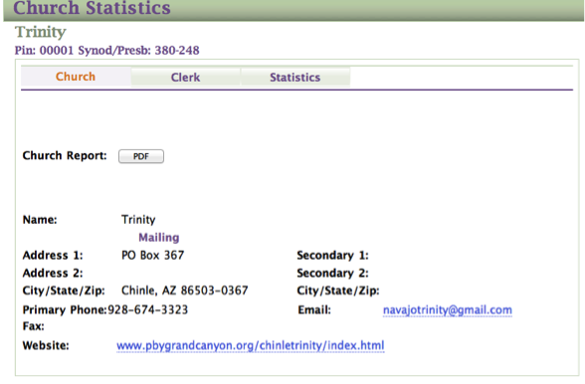
The other option:
After logging into the program, on the right side, you’ll see the option Reports. Below is the portion of the workbook (page 5) explaining how to print.
To print or download a copy of your report press the option “Reports.” You’ll need to work through a series of options.
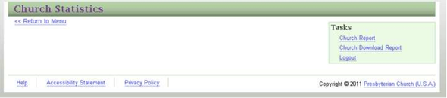

To view or print a copy choose “Church Report.” It will then ask you for the year you would like to view.
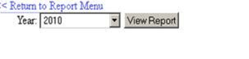
Your report will appear in a box, scroll down to view page one, then use the blue arrow buttons on the top of the page to move to the second page. To print a page use the drop down box that reads “Select a Format.” I suggest using the Acrobat (PDF) option for a clean copy of your report. Press the Export button to download your desired format.

