QMPC Garden Update Spring 2023

Our church started our community garden in the spring of 2013. The garden was started by multiple members of the congregation and we set goals that we achieved over the past ten years. These goals included educating children in our day school, in a day care center in our area and in our summer Sunday school program about gardening and how it tied to God’s Creation.

Our church is located in a food desert and our final goal is to produce food for people in different food deserts in the Lynchburg area.

We identified organizations that would provide food to people in different food deserts as well as people in great need. We worked with the Lynchburg Blue Ridge Food Bank, the Salvation Army, Lynchburg Daily Bread, and Miriam’s House asking the cooks and managers of each organization to review a list of different vegetables that we thought we could raise and see which vegetables their clients would prefer.

Over the years we have planted the vegetables that best suit the needs of these organizations and had the highest yield to reach more people in need. **In 2022 a total of 1130.39 pounds of vegetable were raised and delivered to the above organizations to support the needs of people in Lynchburg.**

We have listed the planting schedules on a diagram of our garden for our Spring, Summer and Fall plantings. We hope that people starting a Community Garden will learn from the goals we have choice and how we decided on what we would plant.

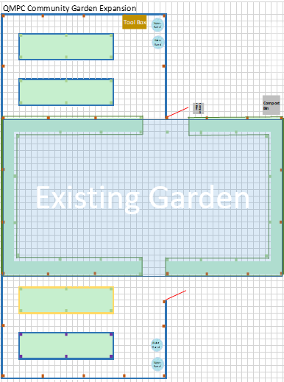

**QMPC Garden planting schedule spring 2023**

**Plant lettuce in raised bed**

**Plant**

**Carrots**

**Plant Romaine in raised bed**

**Plant**

**Romaine**

**Plant Beets in bed**

**Plant 24 broccoli plants in two rows in bed**

**Plant 24 Winter Kale plants in two rows in bed**

**Five Rows in Lower Garden**

1.

2.

3. ----------------- Plant Cabbage 12 plants in ½ row ------=------

4. ----------------- Plant Cabbage 30 plants in one row ------------

5. ----------------- Plant Cabbage 30 plants in one row ------------



**P**

**lant**

**Pole**

**Beans**

**Plant cucumbers/run up fence**

**Plant two rows of Bush beans in raised bed**

**Plant two rows of Bush beans in raised bed**

**Plant 24 Big Boys in bed - 2 rows**

**Five Rows in Lower Garden**

1. Plant ½ row 12 Better Boys --- Plant ½ row yellow Squash

2. --------------- Plant 24 Better Boys in one row ----------------

3. --------------- Plant one row of black beauty zucchini --------

4. ---Skip a row for spacing between squash and zucchini -----

5. ------- Plant one row of straight neck yellow squash ---------

**Plant Pole Beans/run up fence**

**Plant**

**Pole**

**Beans**

**Plant a row of zucchini in bed**

**Plant 36 sweet potatoes plants in three rows**

**Plant 36 sweet potatoes plants in three rows**

**QMPC Garden planting schedule early summer 2023**



**Plant two rows of Cabbage 24 plants**

**Five Rows in Lower Garden**

1. Tomato plants will yield into October

2. Tomato plants will yield into October

3. ------------- Plant a row of purple eye peas ------------------

4. -- Plant one row of Georgia collards 30 plants to the row --

5. -- Plant one row of Georgia collards 30 plants to the row --

**Plant a row of purple eye peas**

**Plant a row of purple eye peas**

**Di g**

**Car**

**rot**

**s**

**Plant purple eye peas**

**Tomato plants will yield into October**

**Dig sweet potatoes the first of October**

**Dig sweet potatoes the first of October**

**QMPC Garden planting schedule late summer 2023**