**KEEPING IN TOUCH**

**Presbyterian Women of The Peaks**

**June 2023 Edition**



**Enjoy your summer!**

**LOOKING FORWARD TO SEEING YOU JUNE 8 – 11!**

**MASSANETTA SPRINGS CAMP AND CONFERENCE CENTER**

**PW SYNOD OF THE MID-ATLANTIC SUMMER GATHERING**

**SPRING GATHERING RECOGNIZES AND HONORS**

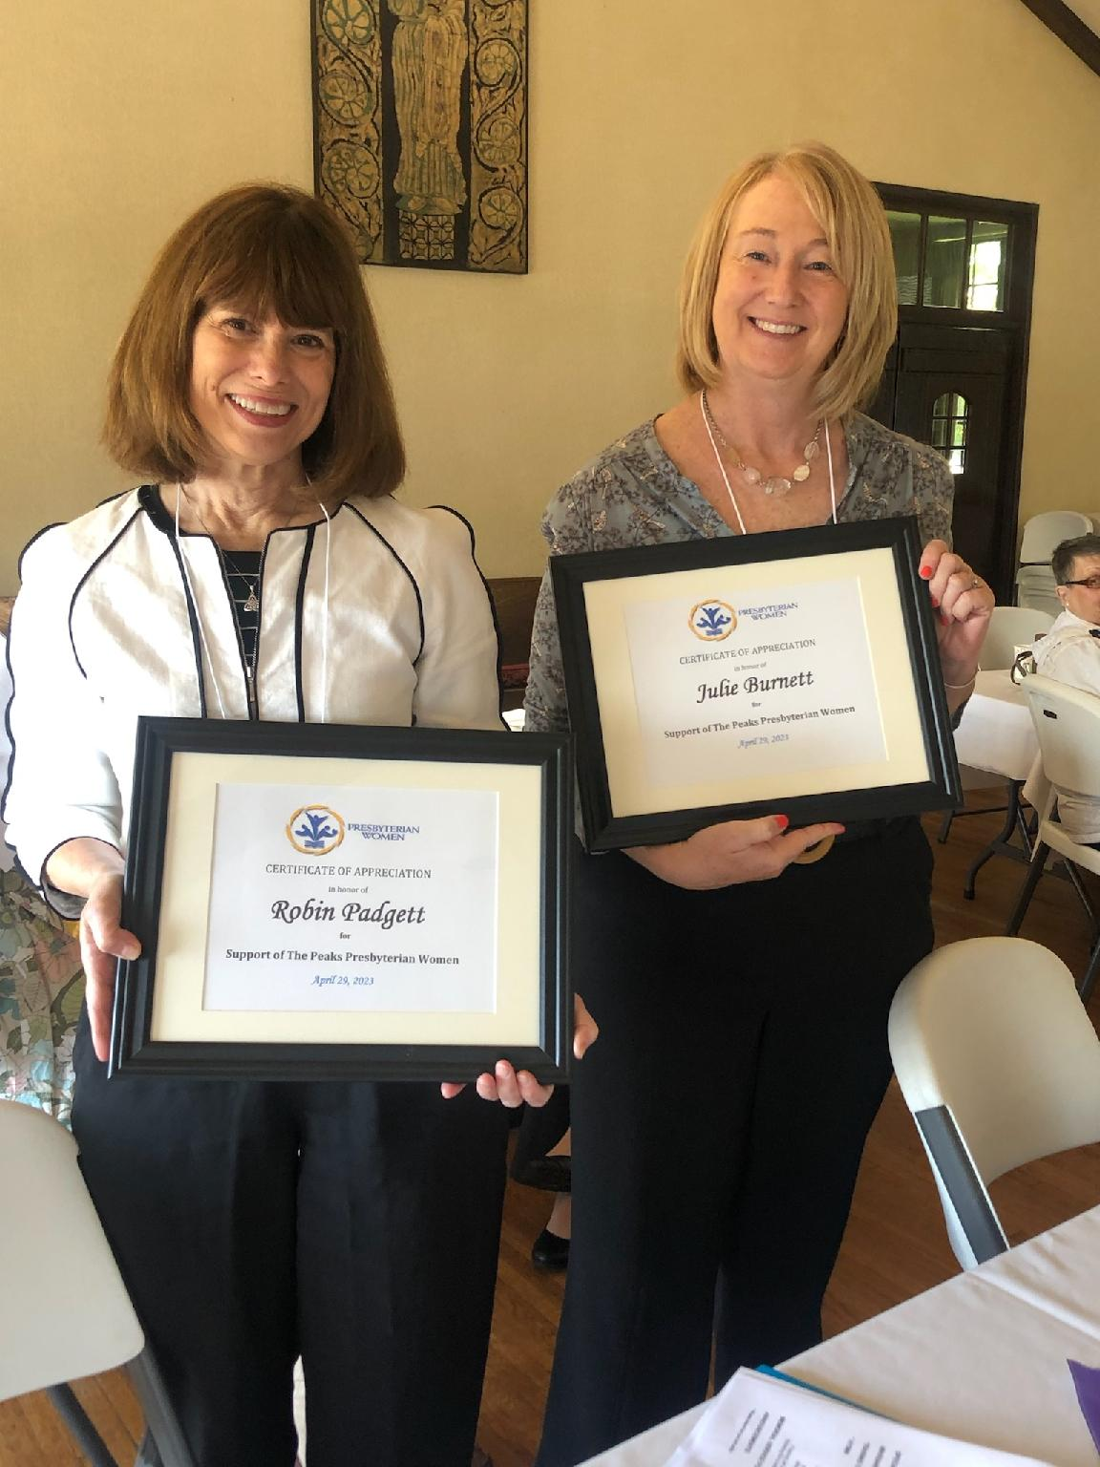**ROBIN JULIE**

**PADGETT BURNETT**

**Accountant and Administrative**

**Office Manager Support**

**CELEBRATING THEIR TALENTS AND**

**THE HARD WORK THEY DO, SOMETIMES BEHIND THE SCENES,**

**TO ENSURE THE SUCCESS OF THE PRESBYTERY OF THE PEAKS**

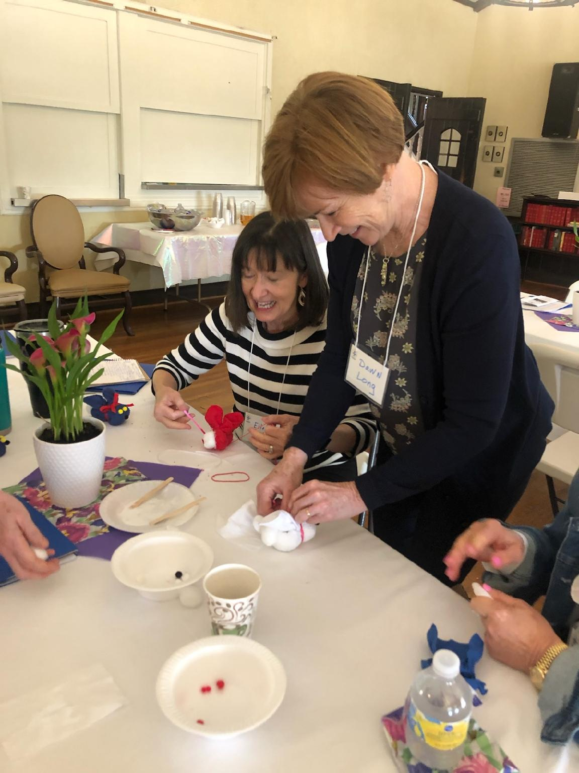**Westminster Presbyterian Church in**

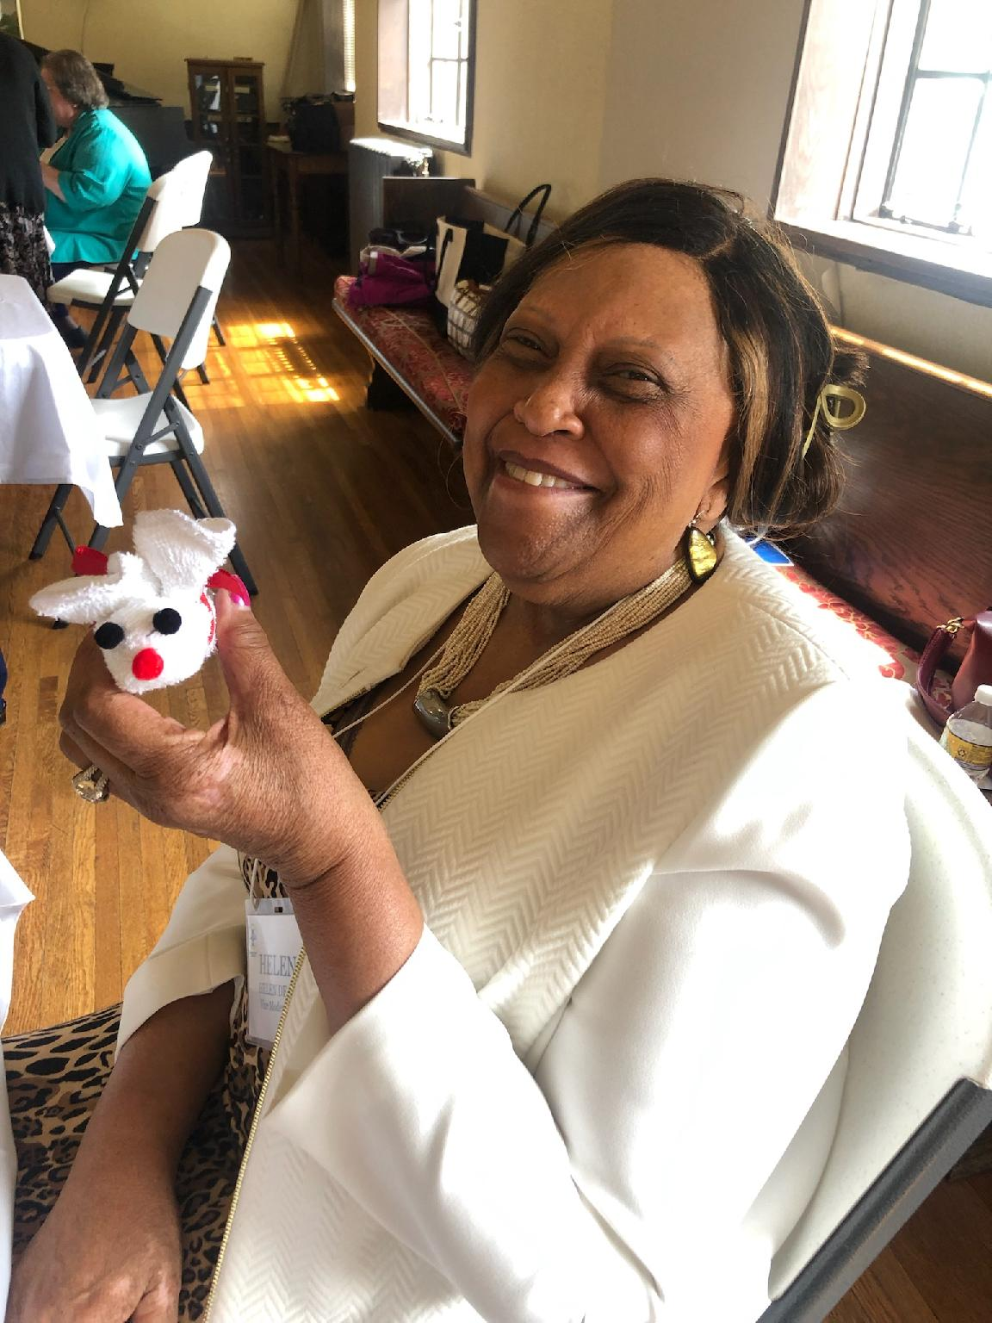**Lynchburg, led by Reverend Shawn Hyska, welcomed 35 PW for the Spring Gathering on April 29. Sarah Hyska, former missionary to Uganda, shared some of her experiences with women’s missions.**

**Participants made washcloth “boo boo bunnies” for**

**children in the Early Childhood Development Program**

**at HumanKind, a nonprofit organization in Lynchburg**

**that has been serving children and families since 1903.**

**HAS YOUR PW GROUP MADE A DONATION TO THE**

**MASSANETTA SPRINGS CAPITAL CAMPAIGN? NEED INFO?**

**Contact Theresa Underwood (**[**tundwood@aol.com**](mailto:tundwood@aol.com)**) or Janet Rakes (jimjanetrakes@comcast.net)**